**Nutrition- ‘Go, Slow, Whoa’ Foods Game**

**Materials Needed**

* Multiple copies of **Handout B-2 “UR What U Eat” from:** [**http://www.nhlbi.nih.gov/health/public/heart/obesity/wecan/downloads/urwhateat.pdf**](http://www.nhlbi.nih.gov/health/public/heart/obesity/wecan/downloads/urwhateat.pdf)**, or** [**http://www.nhlbi.nih.gov/health/public/heart/obesity/wecan/eat-right/index.htm**](http://www.nhlbi.nih.gov/health/public/heart/obesity/wecan/eat-right/index.htm)**.**

***Note: for the Spanish version of this activity, please see the National Heart, Lung and Blood Institute web page dedicated to Education tools and the We Can! Campaign:*** [***http://www.nhlbi.nih.gov/health/public/heart/obesity/wecan/tools-resources/nutrition.htm***](http://www.nhlbi.nih.gov/health/public/heart/obesity/wecan/tools-resources/nutrition.htm) ***and scroll down for links to Spanish language resources.***

Prepare for this activity ahead of time by printing at least 8 copies of **Handout B-2.** You will need to make “game boards.” First, cut only the food pictures squares into separate squares (from all copies). What will be left is just the “Go, Slow, Whoa” along the top, and “Food Groups” along the side. Then, make at least eight (8) copies of those sheets so they become whole sheets of paper. These will be the “game boards.” Shuffle the squares.

***Or, print out Go, Slow, Whoa! Flash cards, found here:*** [***http://www.nhlbi.nih.gov/health/public/heart/obesity/wecan/tools-resources/nutrition.htm***](http://www.nhlbi.nih.gov/health/public/heart/obesity/wecan/tools-resources/nutrition.htm) ***under “Tools.”***

Before playing the game, introduce the concept of “*Go, Slow, Whoa*” foods. It is an easy way to teach children and families to identify healthy and unhealthy foods as either GO (eat almost anytime), SLOW (eat sometimes), or WHOA (eat only once in a while or for special occasions).

Divide participants into groups of 4-6. Give each group a “game board” along with the foods squares (precut and mixed up). Explain that the object of the game is to see who can put all the food items in their correct places on the “game board” page the fastest. Tell them to wait to start until you say “go.” End the activity by handing out the original/complete handout for comparison.

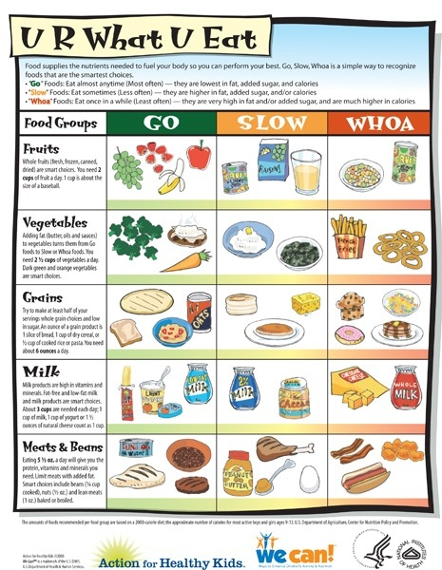**Handout B-2**